**System and Method for Resource Consumption Heatmap Generation within Data Centers**

**Version 1.3**

**June 09, 2021**

**Technology code**

141109 All Real-time prediction, forecasting, and optimization invention

**Inventors**

Praveen Kumar Madhava Rao  
Marius Adrian Cogeanu  
Erik Rueger

Abhigna Valipe

**1. Invention Background:**

**Background**

Modern resource-intensive enterprise and scientific applications create a growing demand for high-performance computing infrastructures. This has led to the construction of large-scale computing data centers consuming enormous amounts of electrical power. Despite the improvements in the energy efficiency of the hardware, overall energy consumption continues to grow due to increasing requirements for computing resources. Worldwide, data centers consume around 40,000,000,000 kW/h of electricity per year and a big portion of this consumption is wasted due to inefficiencies and non-optimized designs. According to the Gartner Report [3], a typical data center consumes the same amount of energy as 25000 households per year, and the electricity consumption by data centers is about 0.5% of the world's production. We propose a cognitive-based energy and resource efficient management system solution for virtualized Cloud data centers that reduce operational costs and provides the required Quality of Service (QoS) using an intelligent self-tuning approach.

**Problem Description**

The importance of energy and resource efficiency in today’s data centers has grown significantly and has become more complex in recent years. To maintain high data availability, all components of the data center infrastructure must perform the assigned tasks to avoid any data center downtime requiring appropriate energy support. The technical infrastructure is fundamental of all information technology (IT) infrastructures and it includes power supplies, technical coolers, and technical security. Any downtime value of the physical infrastructure, no matter how low, has an essential impact on the IT service performance.

There is the need of a more intelligent calculation of the complete resource consumption for a single system (from building a system, implementing, usage, maintaining and recycling) projected into an overall data center to optimize workload balancing based on resource consumption.

**Known Solutions**

There are different approaches focused to save energy but not overall resource consumptions. Most of the solutions are focused on saving power with cooling. Cooling can make up about 40 percent of the overall power consumption in a data center, then you have about 30 percent for the servers, then you have less for the UPS systems, a little bit for the lights, and so on. An efficient approach is water cooling, and we can do it in totally different ways. We can cool the processor directly on the motherboard – tiny copper pipes, cooling with water or oil. This is common in high-performance data centers for scientific uses. And we have a different approach to using water to cool the rack doors, so we have hot air running through the server, and on the back door of the server rack, this hot air is cooled down. The heat goes into the water cycle and is taken out of the data center (this is the method used by e3Computing, for example). This is much more efficient than using air-water which has a greater capacity to transport heat instead of air, so then you need less power to transport the heat through the water rather than the air. We need huge fans to transport air. So this is an efficient approach, but a lot of data center providers don’t like the idea of having water in the server room.

Secondly, Great importance has to be given to the monitoring and event management of all existing component parameters, including energy usage management in the data center infrastructure system to avoid or prevent any downtime.

When designing a computer data center from the point of view of support infrastructure, the necessary capacity has to be ensured for the main and the backup supplies, uninterruptible power supplies (UPSs), system and communication cabinet capacities, technical cooling, and for any other elements of electrical and cooling power supply. It is of utmost importance that data centers are adequately resistant against any support system downtimes. As these support systems are part of the support infrastructure, which is also referred to as technological systems, the goal of this research was to monitor all possible parameters that are crucial for the data center operation and to detect any faults in the shortest time possible (from their occurrence on) and generate the heatmap. Using that as an input as a predicting factor to the cognitive system, the load balancer predicts when additional UPS or coolers need to be used, both during the operation as well as during the data center upgrades. It is noteworthy that the reduced time to detect the faults significantly improves the availability of data centers

**2. Invention Summary:**

**Summary**

Data centers have been found to consume high amounts of energy. “It has been estimated that the cost of powering and cooling accounts for 53% of the total operational expenditure of data centers”.

The rapid growth of the demand for computational power by scientific, business, and web-applications has led to the creation of large-scale data centers consuming enormous amounts of electrical power.

We propose a cognitive-based energy-efficient resource management system and method based on resource consumption heatmap generation for virtualized Cloud data centers that reduce operational costs and provides the required Quality of Service (QoS).

Energy consumption means not just electrical energy, it does mean the overall required resources like energy from the creation of a system, the operation, the maintaining and the recycling consumption. This consumption in relation to usage will generate the individual workload consumption curve for each system and be used for consumption heatmap optimization within datacenters.

* On the vertical - Resource Consumption and on the horizontal - Workload
* **Green** line represents the **System build** (resources to create a system)
* **Red** line - **Recycling** costs for this individual system (fixed block)
* **Blue** line – **Maintenance** costs – constantly increasing with new workload
* **Black** line – System **operation** (power, floor space, cooling) (run system costs)
* **Orange** line – The **individual overall** consumption curve for individual system
* On the right side you can see the Blue Green Red
* When a system is in the blue area (underload) it is an indication that the system can be used more
* Each system should stay in the Green Area
* Red area represents Overload and should be avoided

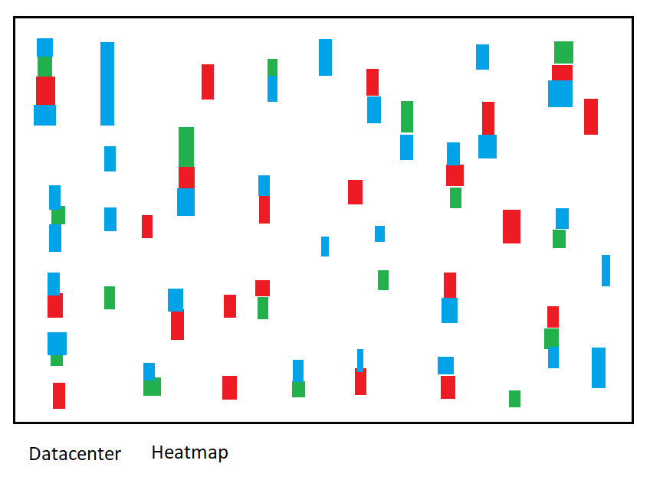

* A representation of systems in their current state of operation (Workload Heatmap)
* Each box on the Heatmap is a single system in the entire Datacenter
* Applying more workload on a Blue System will become Green
* Applying more workload on a Green System will become Red.

**Novelty claims**

System and Method for Resource Consumption Heatmap Generation within Data Centers by:

* Capture system-relevant calculation parameter.
* Calculate system-specific resource consumption curves.
* Generate overall Data Centre Heat map based on resource consumption.
* Proactive resource utilization with the usage of generated heat map
* Dynamic resource allocation with the usage of generated heat map
* Allows intelligent decision management and resource efficiency.

**Advantages**

Solving the lack within Data Center between usage and resource consumption optimization by having the right workload assigned to the right system to minimize the resource consumption.

Solving the lack of dynamic resource mapping for Data Centre(analytic).

Solving the lack of proactive (cognitive) & portable (mobile) bandwidth management.

Enablement of Individual support system efficiency computation

Generation of High Availability for systems

Cognitive logic is adaptable to new, improved and changing solutions.

The cognitive logic is configurable.

**Problem Solved**

Minimize overall Resource consumption

Efficient Workload Management

Elimination of power waste

Reduction of operational costs

Reduction optimization of maintenance costs and consumptions

**Infringement**

The proposed solution can easily be detected by analyzing product documentation or reading sales materials.

**Non-obviousness**

The calculation combines advanced knowledge from multiple knowledge domains and hence it’s not obvious.

**3. Invention Details:**

When designing a computer data center from the point of view of a support infrastructure, the necessary capacity must be ensured for the main and the backup supplies, uninterruptible power supplies (UPSs), system and communication cabinet capacities, technical cooling, and for any other elements of electrical and cooling power supply.

The overall power consumption of a data center is related to the associated power consumed by each unit. Efficiency at individual parts is an important step for “greening” the data center but optimization is achieved when the efficiency aims to the overall data center design.

First, the assumption that the losses associated to the power and cooling equipment’s are constant with time is wrong. It has been observed that the resource efficiency of these equipment’s is a function of the IT load and presents a nonlinear behavior. The goal of this idea is to analyze the behavior pattern at various times by generating a consumption heatmap and propose directions for resource consumption by quantizing its performance using cognitive analytics.

The figure below shows the main high level process flow

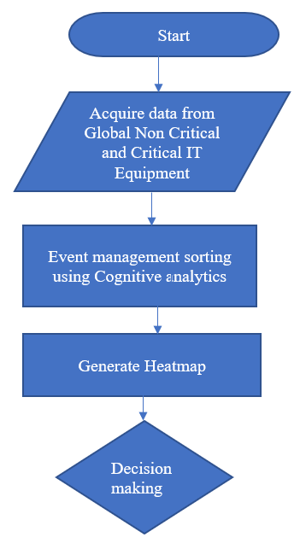

**Dynamic Data Center Efficiency Management Logic:**

Data centers encounter power waste in the non-critical equipment’s and in the critical equipment’s.   
The metrics that best define the non-critical equipment’s efficiency are the Effective Power Usage (EPU) and the Efficiency of Data Center (EDC).

CMV= Cognitive mean value   
ITR= Iteration  
EPU= the ratio of the total facility input power over the power delivered to IT.  
EDC= inverse of EPU  
EPU= Power IN/ Power IT = LFC + LFP  
LFC= Load Factor for cooling  
LFP= Load Factor for power

where LFC represents the cooling load factor normalized to IT load (losses associated to chillers, pumps, air conditioners) and LFP represents the power load factor normalized to IT load (losses associated to switchgear, UPS, PDU). These metrics characterize the performance, or the power wasted in the non-critical components of the data center.

For e.g.: The Cognitive mean value of the measured EPU is 1.83 or 0.53 (53%) EDC This means that almost 53% of the power that enters the data center is wasted for cooling and power delivery in the non-critical components. The remaining 47% is used for data processing.

The formulation is

EDC= Computation/Total Energy (Power IN) = (1/EPU) * (1/SEC) * (Computation/Power IT) *ITR(i)

SEC= Server Energy Conversion

captures inefficiencies caused by non-critical equipment of the IT equipment. These can be the server’s power supply, voltage regulator modules and cooling fans.

SEC = the ratio of the total server input power over the useful server power, i.e. the power consumed by motherboards, CPU, DRAM, I/O cards, etc. The combination of EPU and SEC measures the total losses associated to non-critical components that exist in the data center’s NCPI and IT equipment’s.

CEU = Total Measured Energy of IT [kWh]  
 _____________________________________________  
   
 Total Specification Energy IT (by manufacturer) [kWh]

CEU= Cognitive Energy Unit

is the average utilization factor of all IT equipment included in the data center and can be considered as the degree of energy saving by this technique and operational technique that utilize the available IT equipment capacity without waste.

CEE = a · server capacity + b · storage capacity + c · NW capacity Total Specification * ITRi  
__________________________________________________________________________

Energy IT (by manufacturer) [kWh]

CEE= Cognitive Energy Efficiency

GDC= Green Data Centre

GDC= Green Energy/ DC Total Power consumption

CDPE= Cognitive Data center per Energy

CDPE= Data Center Work/Carbon Energy= CEU x CEE x 1/EPU x 1/1-GDC* ITRi

MV= Maintenance Value (to be differentiated from the Maintenance Mode) – the value will get incremented when the device has a good performance in each time frame. Every device will be measured in terms of maintenance for a particular period. The customer should be able to see which manufacturer outperformed and not to be replaced at all. The maintenance value can be increased or decreased depending on the performance of the system.

Finally, GDC is the available “green” energy that the data center is supplied additionally to the grid electricity. The higher the value of CDPE the less the carbon emissions it produces and more energy efficient it is.

Having Generated the heatmap based on the above illustrations, the grid values are sent to the real-time feedback system that uses iLOG/CPLEX. The iLOG/CPLEX routing algorithm does the remote monitoring as a RADAR on both the Critical and Non-Critical equipment individually and effectively co-ordinates with Workload Analyzer and Non-Critical Resource manager creating an activity profile at times of varying input workloads retiring servers that are no longer in use or recommendation of consolidation. On the other hand, according to the workload that enters the UPS, the efficiency can vary from 0% at no load to 95% at full load in a nonlinear way. Taking into consideration that common data centers operate at 30–40% of their maximum capacity workloads, the efficiency of the UPS cannot be considered constant and equal to the imposed by the manufacturer value. Insufficient or malfunctioning cooling system can lead to overheating of the resources reducing system reliability and devices lifetime. The iLOG/CPLEX acts as a Radar and proactively monitors the transition of workload in varying frequencies and put the UPS in standby mode when not in use and PDU to distribute the power according to the supplied workload.

The novelty relies in the monitoring the efficiency of individual devices both critical and non-critical equipment’s and ability to optimally interact with the servers with a balanced approach for server consolidation or retiring and supply of storage and processor as required to support resource efficiency using intelligent tuning/decision option by cognitive analytics.

Individual curve illustration of a single system:

The DC Framework consists of two basic modules -   
(a) Workload Analyzer  
(b) Resource Manager/Scheduler

The Workload Analyzer calculates the capacity bandwidth required based on the below parameters and send it to iLOG/CPLEX for the computation of curve and prioritize the resources using the resource manager  
(a) number of requests measured at the servers and the available bandwidth  
(b) number of servers which are idle at the time  
(c) number of servers which are underutilized and can be consolidated ${bw}_{capacity}-req=\sum_{i=1}^{n}{request*bwper-request}-idle_{server+Underutilized_servers}$

**Workload Trace Table**

|  |  |  |  |  |  |
| --- | --- | --- | --- | --- | --- |
| Trace | Description | Avg load | Mean Time Arrival | Avg job runtime | Rank |
| SDSC | **San Diego Supercomputer** | **56%** | **5.2 Min** | **30.6 Min** | **2** |
| IBM BLR | **IBM Ballerup** | **28%** | **6.8 Min** | **30.5 Min** | **1** |
| CISCO RT143 | **CISCO Routing Terminal** | **30%** | **3.2 Min** | **60.8 Min** | **3** |

**Cognitive Transition & Design Principles:**

* Administrator/ user install SAM as one time installation
* Put the cognitive agent service in listening mode
* Create a use case and register the parameter in behavior model set database which is basically a
* Repetitive action done manually using a set of commands.
* Resource allocation done manually at different frequency intervals.
* Consistent deployments
* Service automation
* Create a Resource Endpoint Service Manager
* Create services for non-critical devices and critical devices with system specific parameter
* Create an activity profile for every device with eventviewer
* Create a Resource Manager group and assign all the services
* Create an Usecase scenario and update it to Knowledge database
* Confidence percentage set to Zero and start iteration 1.
* Events classified into Frequently occurring and less frequently occurring
* Once the services are trained the Administrator changes the service to Notification mode to send email and Mobile Notification
* Once the Knowledge Database and behaviour database achieves 100 percent confidence percentage after several iterations then Administrator place the service in reactive mode.
* The successful resolution report can be downloaded from the profile -> reports.
* The successful KDB can be downloaded as a template and can be used to other data center.

All Infrastructure Iteration 1

Event Scanner

Administrator

**Prior Art**

Event NL Inputs 22

Event Error Codes 20

Cognitive Agent Module

Event Analyzer  
Is Event a real issue?

AI Platform –

Frequency count value

Knowledge Database

Maintenance Value

Behavior Database

Increase

Confidence Percentage

Solution preexists

Machine Learning

Frequency count value = Frequency count value +1

Maintenance Value = Maintenance Value +1

Rank and Retrieve Discovery process

Natural Language Processor

Solution Availability Module

Feedback ILOG CPLEX System

* Every successful problem resolution will be recorded in the Behavior Database and Knowledge Database
* Solution steps/ Known solution technical commands will be coded in the Solution Availability module
* Once the Solution is confirmed as IBM Best practice then it is sent to Feedback ILOG CPLEX system for decision making
* Every individual device is tracked by workload analyser metrics and ranked by cognitive rank and retrieve service
* The human problem solving is encoded by Natural language processor and fed into the Knowledge database.
* Orchestration of all services can be found in Global Non physical infra manager and Resource manager.
* Thermal heatmap indicator value –   
  Blue – indicates matches the Cognitive Energy Efficiency metric value.   
  Yellow – Deficiency in some of the resources that need attention but the infrastructure is still manageable

Red – Require immediate attention

* Every Device connected is paid special attention and monitored by a service every minute which can be visualized through dashboards and can be further drill down to activity profile which describes the overview of the device and device event viewer logs the error with timestamp.
* Problem resolution will be carried out by Administrator by enabling the cognitive service and communicating in Natural Language English and executing the commands processed by NL processor as shown in the above diagram.
* The confidence percentage count will get increased if the problem repeats and steps to resolve remain the same.
* The Solution Availability manager is the database that contains the solved problems as per IBM Best practices that will be done automatically when the cognitive system take control and declaratively start issue the commands/prioritize the resources according to the demand.
* Visual workflow can be seen in the User Interface monitors as how the resources are allocated and current efficiency value will be displayed in Thermal heatmaps.
* Activity step and decision step can be checked and controlled by human intervention and scheduled jobs as without intervention.
* Resource cost Explorer – Reports on cost level of resource managed hourly with a better break down of understanding of cost saving using the CPE metric value. Waste report contain the devices that are malfunctioned or consistent failures that are eliminated as per the Resource manager.
* Manage, Create, Update and Delete Resources using the Resource Manager.

**Current opportunity Example:**

Company ‘A’, an online Indian grocery store which operates across [Czech Republic](https://dookan.com/), [Germany, Austria, Slovakia, Hungary, Italy and Luxembourg](https://eu.dookan.com/) owns a corporate data center in Prague and Germany. The problem they see currently is the resource management is currently done manually during the peak and off-peak periods and most of the times the devices are not reliable and insufficient.

The company wants to have a cost-effective resource management solution to manage the resource allocation as the orders peak during Friday for weekend delivery and wanted to have a detailed analysis on the reliability of the devices with core checks and recommendations.

They wanted to see the notifications and recommendations on device level with waste analysis report for the last 30 days.

Our solution can help in that case to provide information’s of the the resource allocation during the peak and off-peak hours and the behavior trends which are effectively monitored. The company will see cost saving as also time saving in terms of effective resource allocation strategy handled for the system and maintenance and reliability of overall devices.

Company ‘B’ has noticed that its application performance has degraded recently and the queries take longer time to execute and sometimes the application halts.

The problem with inefficient database queries is that they’re difficult to detect until it's too late. For example, a developer may experience very little lag with a small sample database and just with his local machine, but a production-level number of simultaneous queries on a much larger database could grind the entire application to a halt.

Our solution can help using the monitoring dashboard lists core checks and provide keen statistics of databases when a problem occurs. Upon investigation, the team found out that its due to missing indexes and allocation of more memory required.

Recommendation from the dashboard using the behavior model is to modify the amount of memory allocated to the database using the innodb_buffer_pool_size key in MySQL’s configuration file my.cnf.

**A prior art search was conducted by the team**

The following are search strings used by inventor team for prior art search:

<<Heat map Generation>> <<Green Data Center>> <<Resource Efficient Data Center>> << Resource Consumption>>

The following prior art was found:

1. Data Center Operation Optimization

Type: Data center optimization

URL: https://patents.google.com/patent/US20090113323A1/en

1. Method and apparatus for power management using distributed generation

Type: Power Management using distributed generation

URL: https://patents.google.com/patent/US9800052B2/en

1. A kind of data center intelligent management system based on radiofrequency (RF) identification and method

Type: Data Center intelligent management system of monitoring done through radiofrequency identification and method

URL: https://patents.google.com/patent/CN102436610B/en

|  |  |
| --- | --- |
| **Prior Art** | **Differentiation** |
| [US20090113323A1](https://patents.google.com/patent/US20090113323A1/en?oq=energy+efficient+data+center+using+heatmap) – Data center interaction method comprising acquiring the data from multiple sources and rendering the data spatially in real time. | Our idea takes input from all the critical and non-critical infrastructure support systems to provide energy efficient output using cognitive computing. |
| [US9800052B2](https://patents.google.com/patent/US9800052B2/en?q=green+data+center&oq=green+data+center) – Embodiments of the subject invention relate to a method and apparatus for providing a power demand shaping (PDS) technique by utilizing load following with distributed generation (DG) systems, to meet time-varying power demand. | The goal of our research is based on the efficiency of individual units and optimization. |
| [CN102436610B](https://patents.google.com/patent/CN102436610B/en?q=green+data+centre&oq=green+data+centre) - A kind of data center intelligent management system based on radiofrequency (RF) identification and method. | The novelty of our idea relies on optimization of energy through real time monitoring thru generation of heatmap and intelligent decision making to balance the workloads. |